**Test Case and Bug Reporting**

Project management tool JIRA

Scenario Based Questions:

Q1.Write as many test cases as you can for a given scenario using Excel sheet .The Excel sheet should include the following columns:

https://in.bookmyshow.com

• Test Scenario ID(Requirement Matrix/User Story): A unique identifier for each test case.For Ex:TS-1,TS-2,TS-3...TSn.

• Test Scenario: A brief description of the test case.

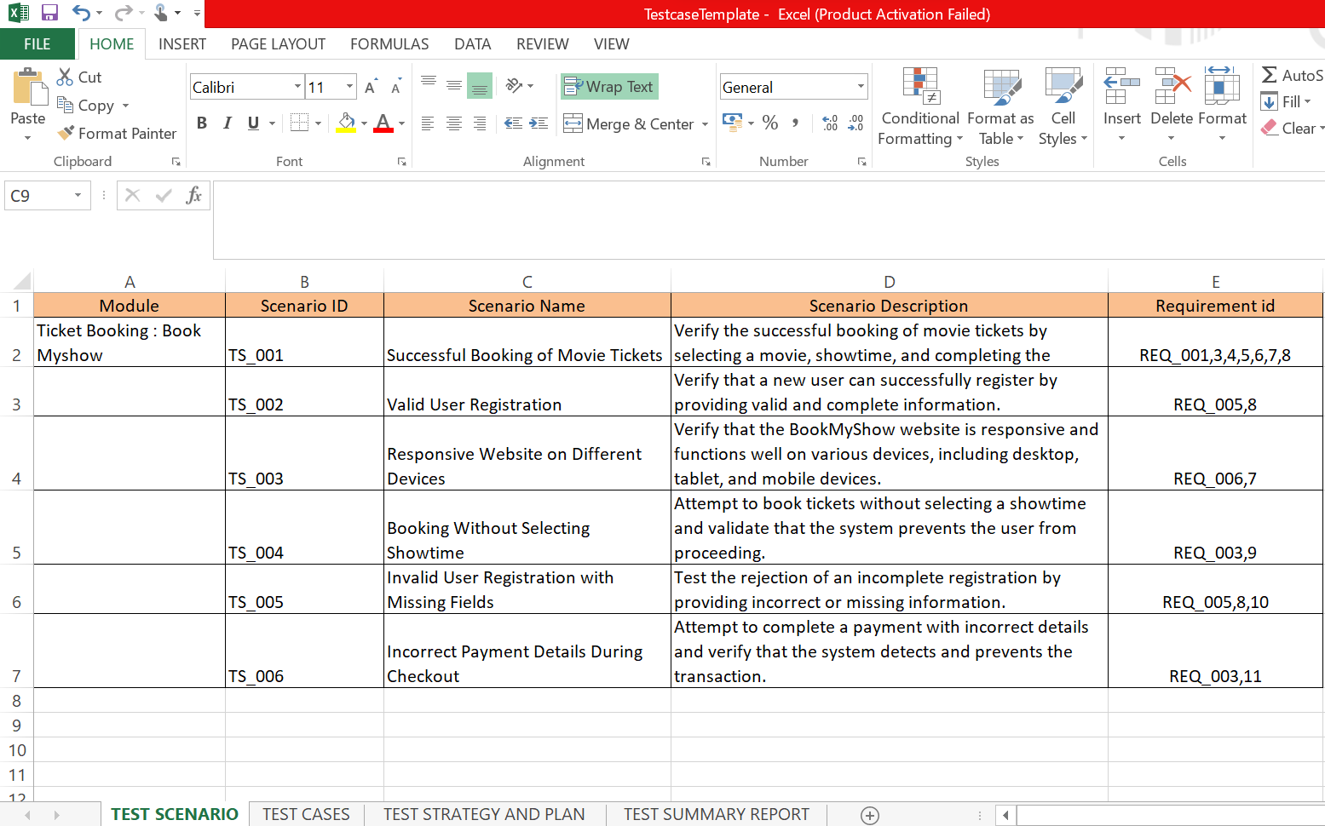

• Test Case ID: A unique ID for testcase Forex: TC-1,TC-2....TCn

• Test Steps: A detailed list of the steps to be followed to execute the test case.

• Input:The input of each step taken by user.

• Expected Results: The expected outcome of each step in the test case.

• Actual Results: The actual outcome of each step in the test case.

• Pass/Fail: Whether the test case passed or failed.

• Test Case Complexity

• Test Case Severity

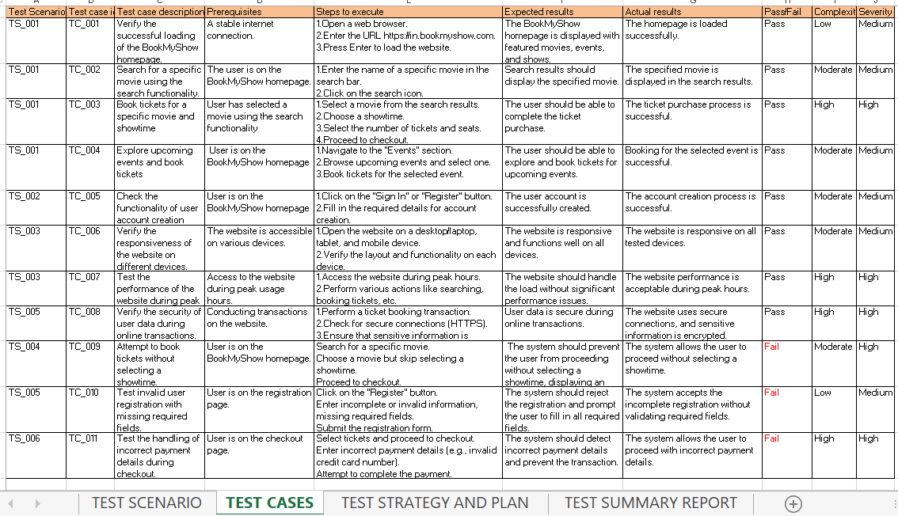

Q2. Write the key points on Test Scenario,Test Case, Test Strategy and Plan, Test Summary Report.

**Test Strategy**

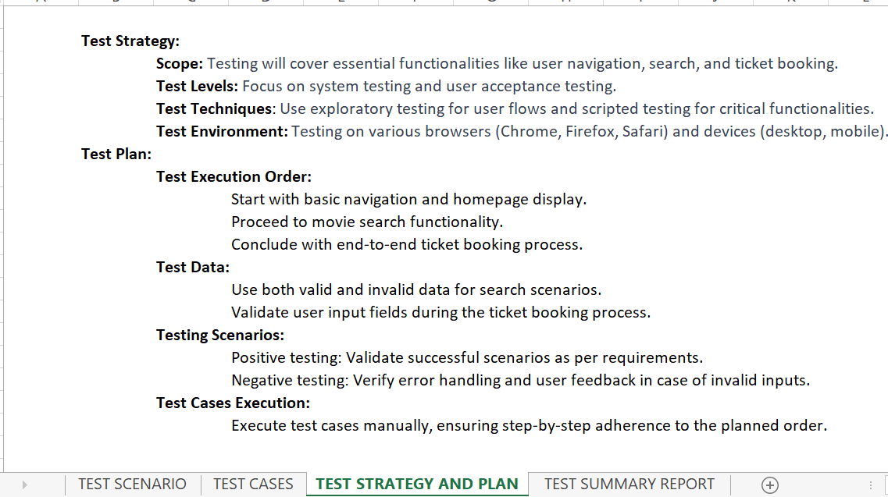

**Test Summary Report.**

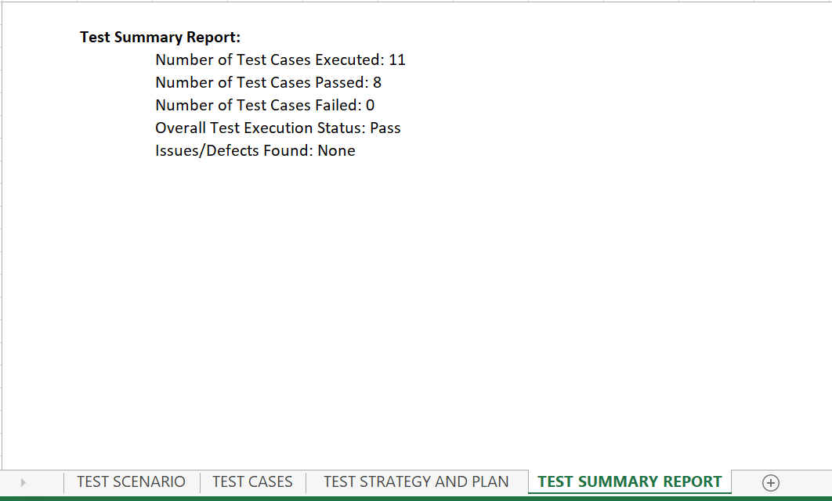

**Upload Bulk test cases into Zephyr Squad**

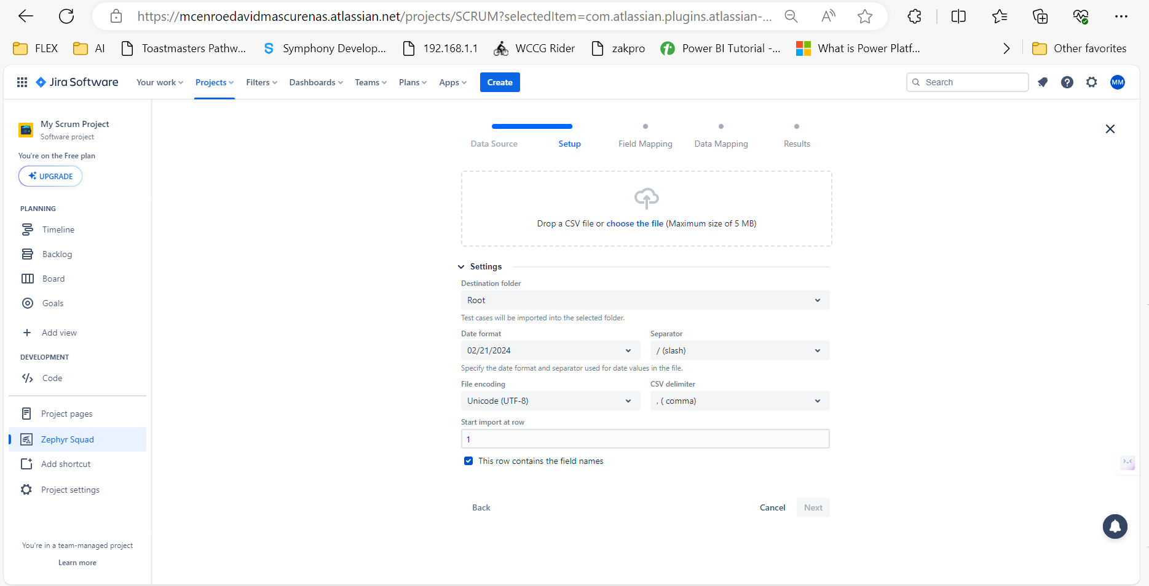

**Input CSV File**

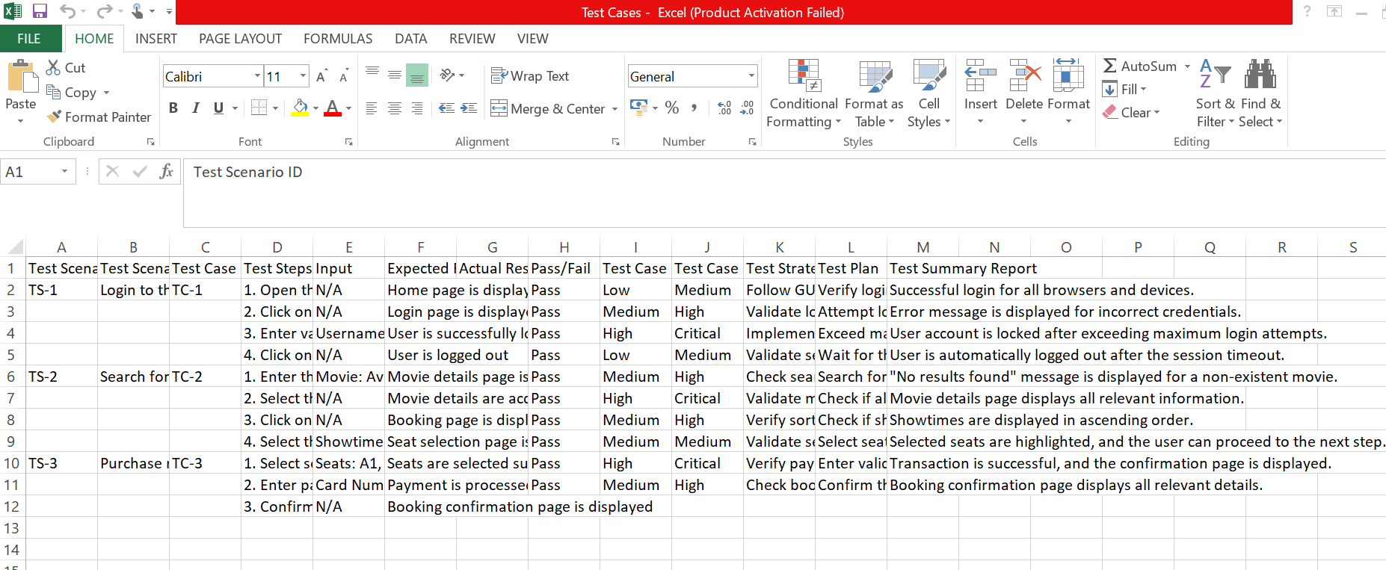

**CreateTest case by mapping the fields**

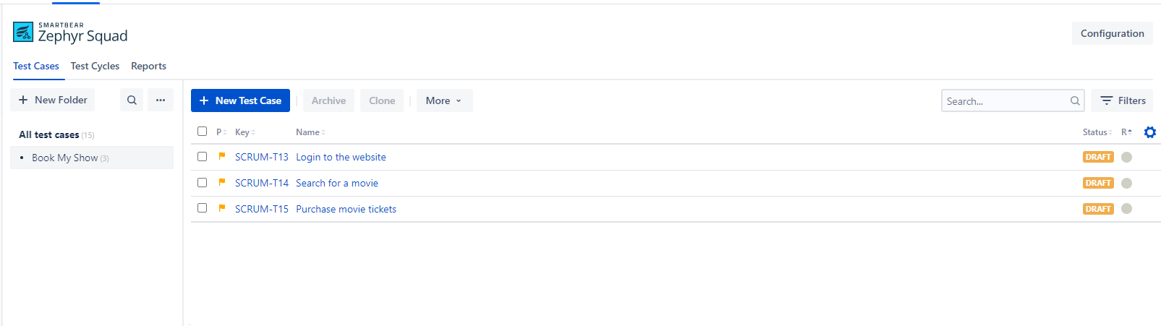

**Created New Test Cycle**

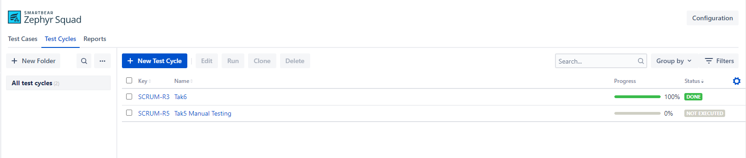

**Adding test cases into the (Task 5 Manual Testing)**

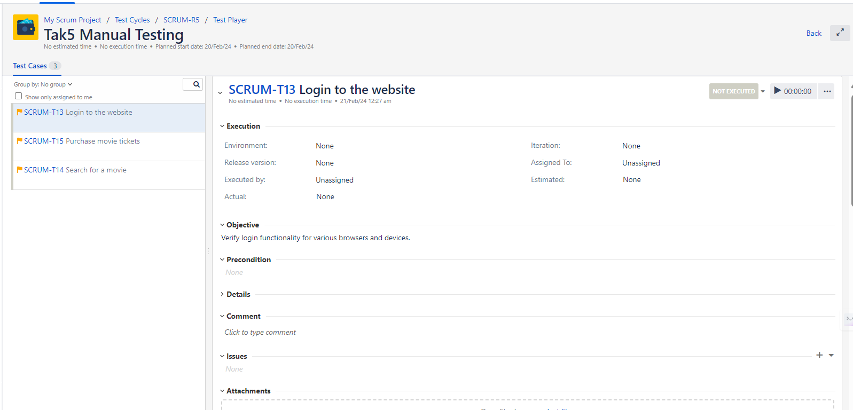

**Validate the test cases**

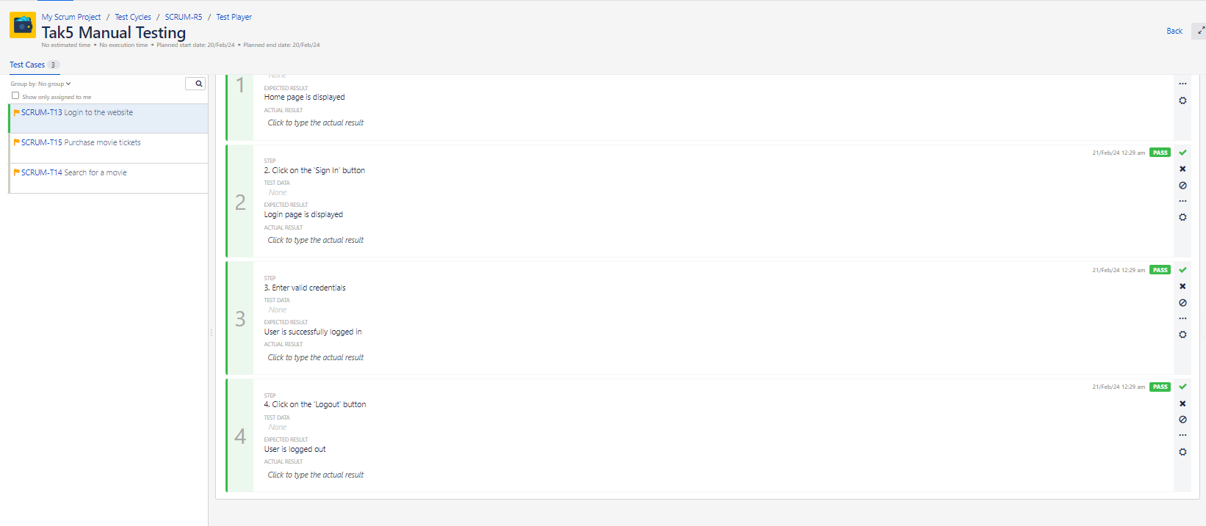

**Complete test case in zephyr Squad**

